# **Over-View of Data Visualization**

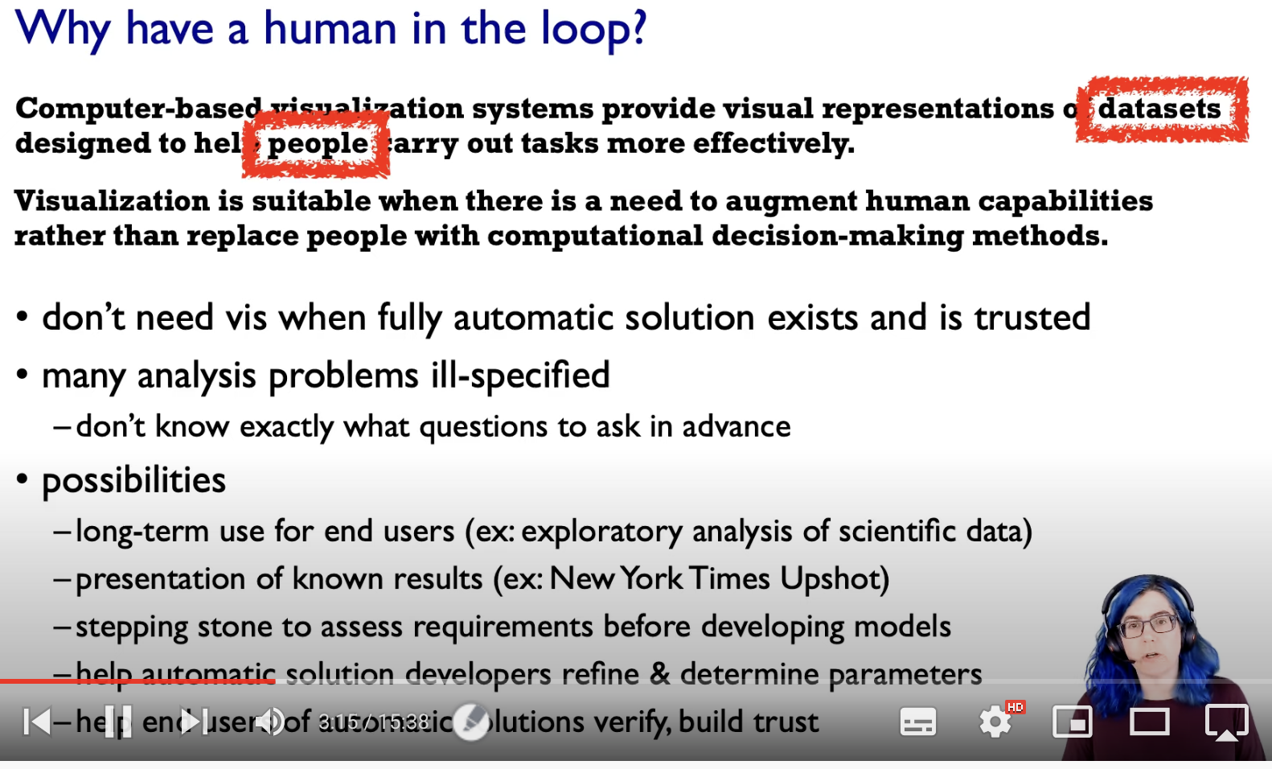

To replace cognitive acts with perceptual acts, in-order to free up the cognition for more interesting typically higher level questions than the really lower level ones.

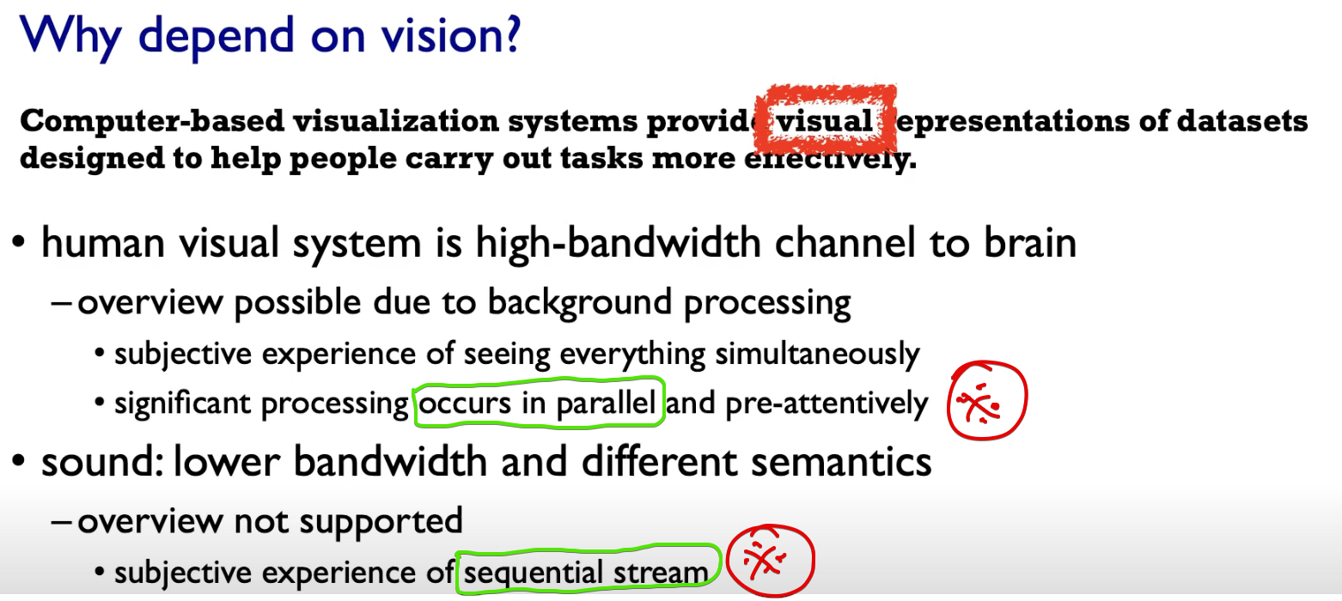

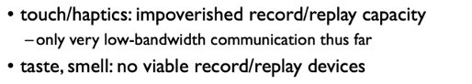

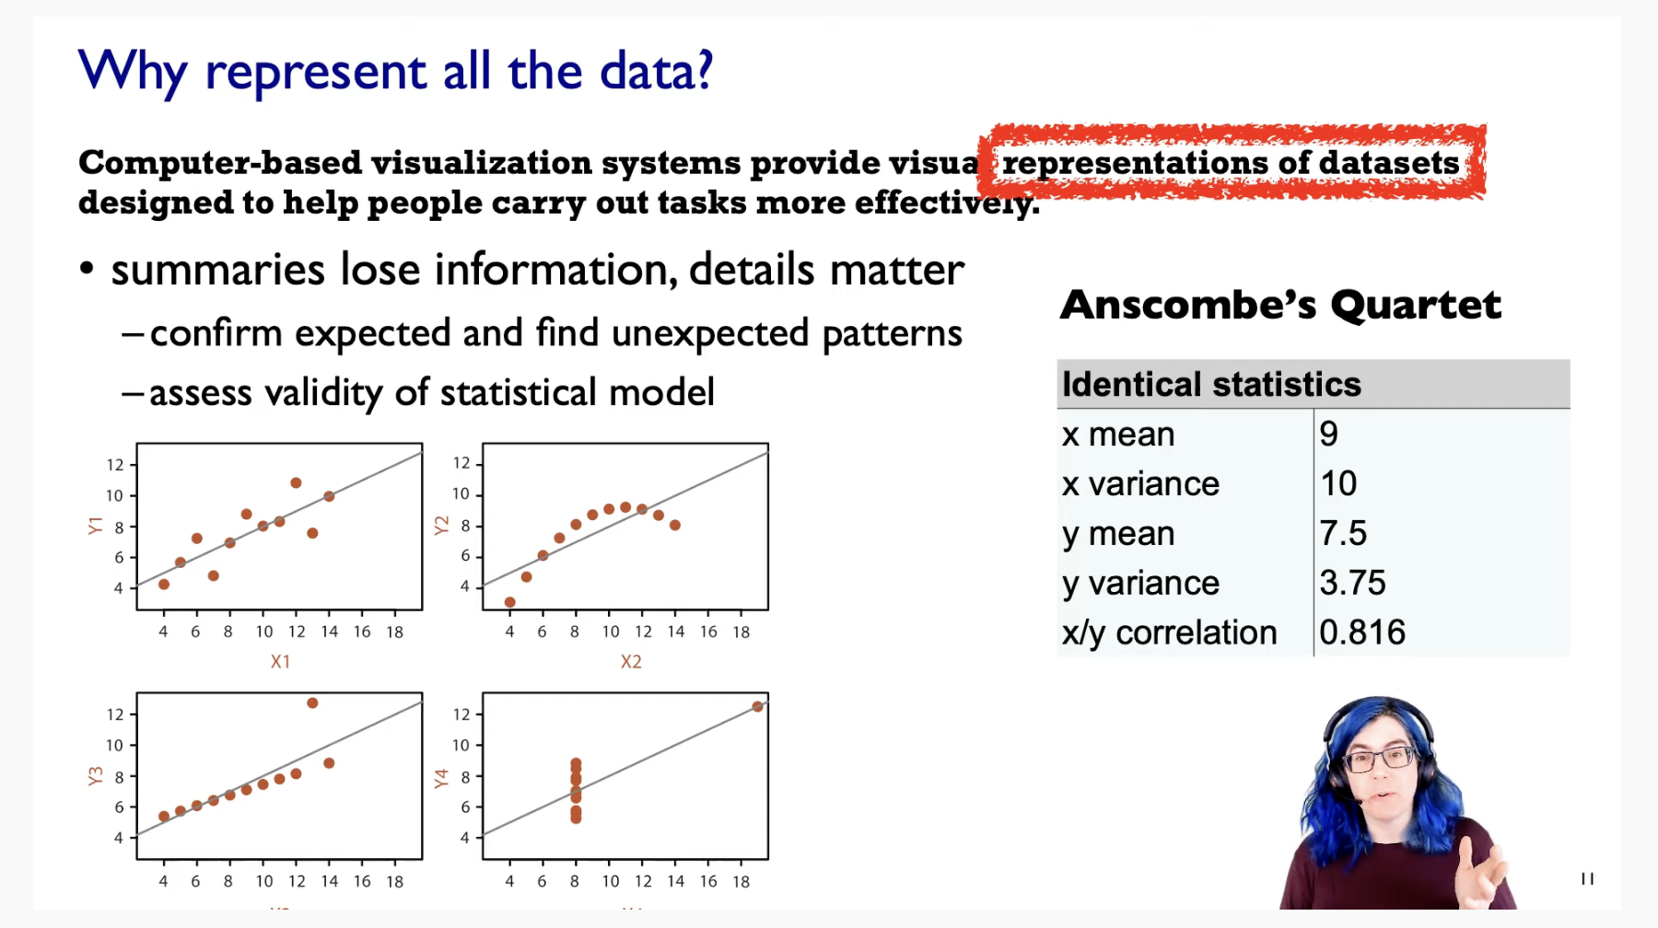

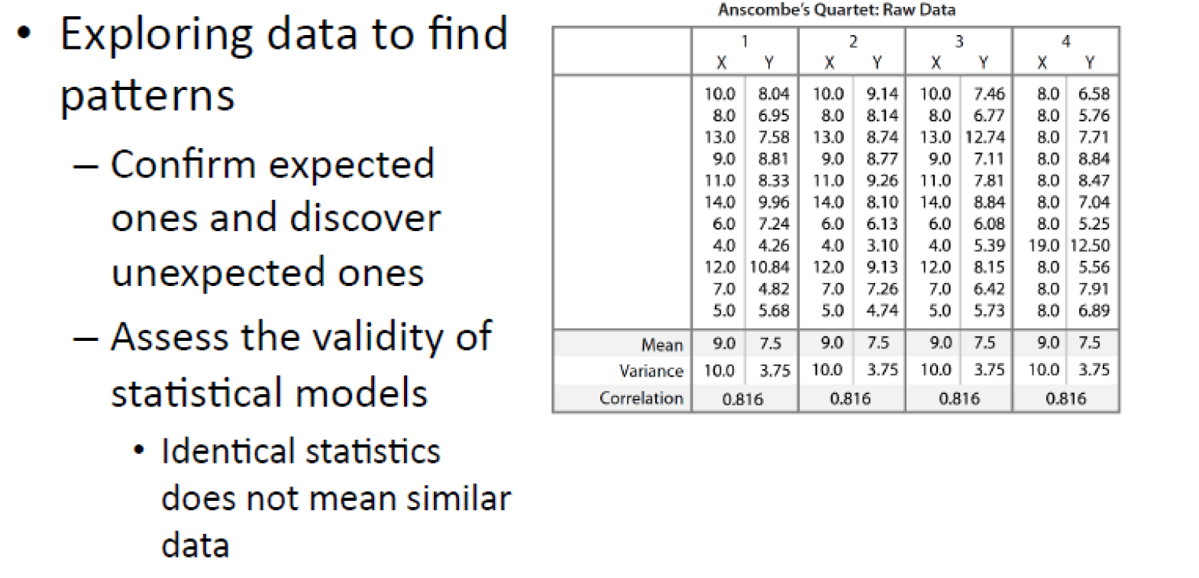

Though the mean, variance of X and Y ; Correlation of 1,2,3,4 🡪 same  
On visualization, there was a greater change in the visualization.

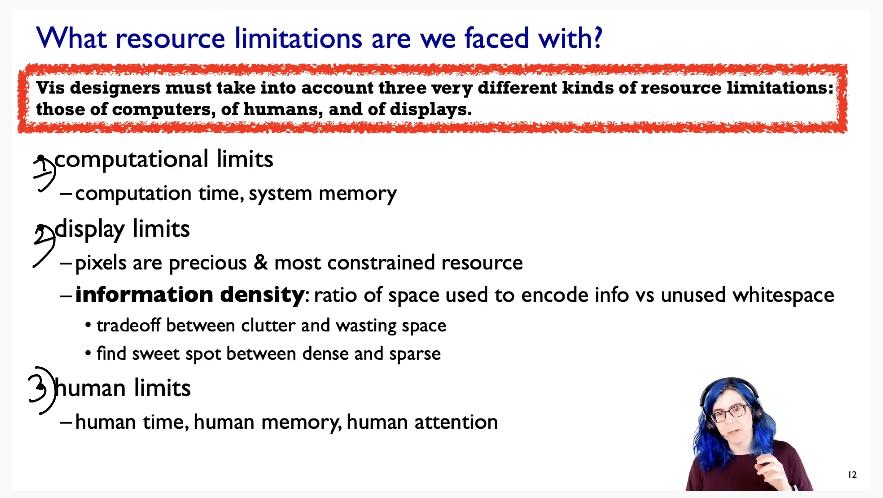

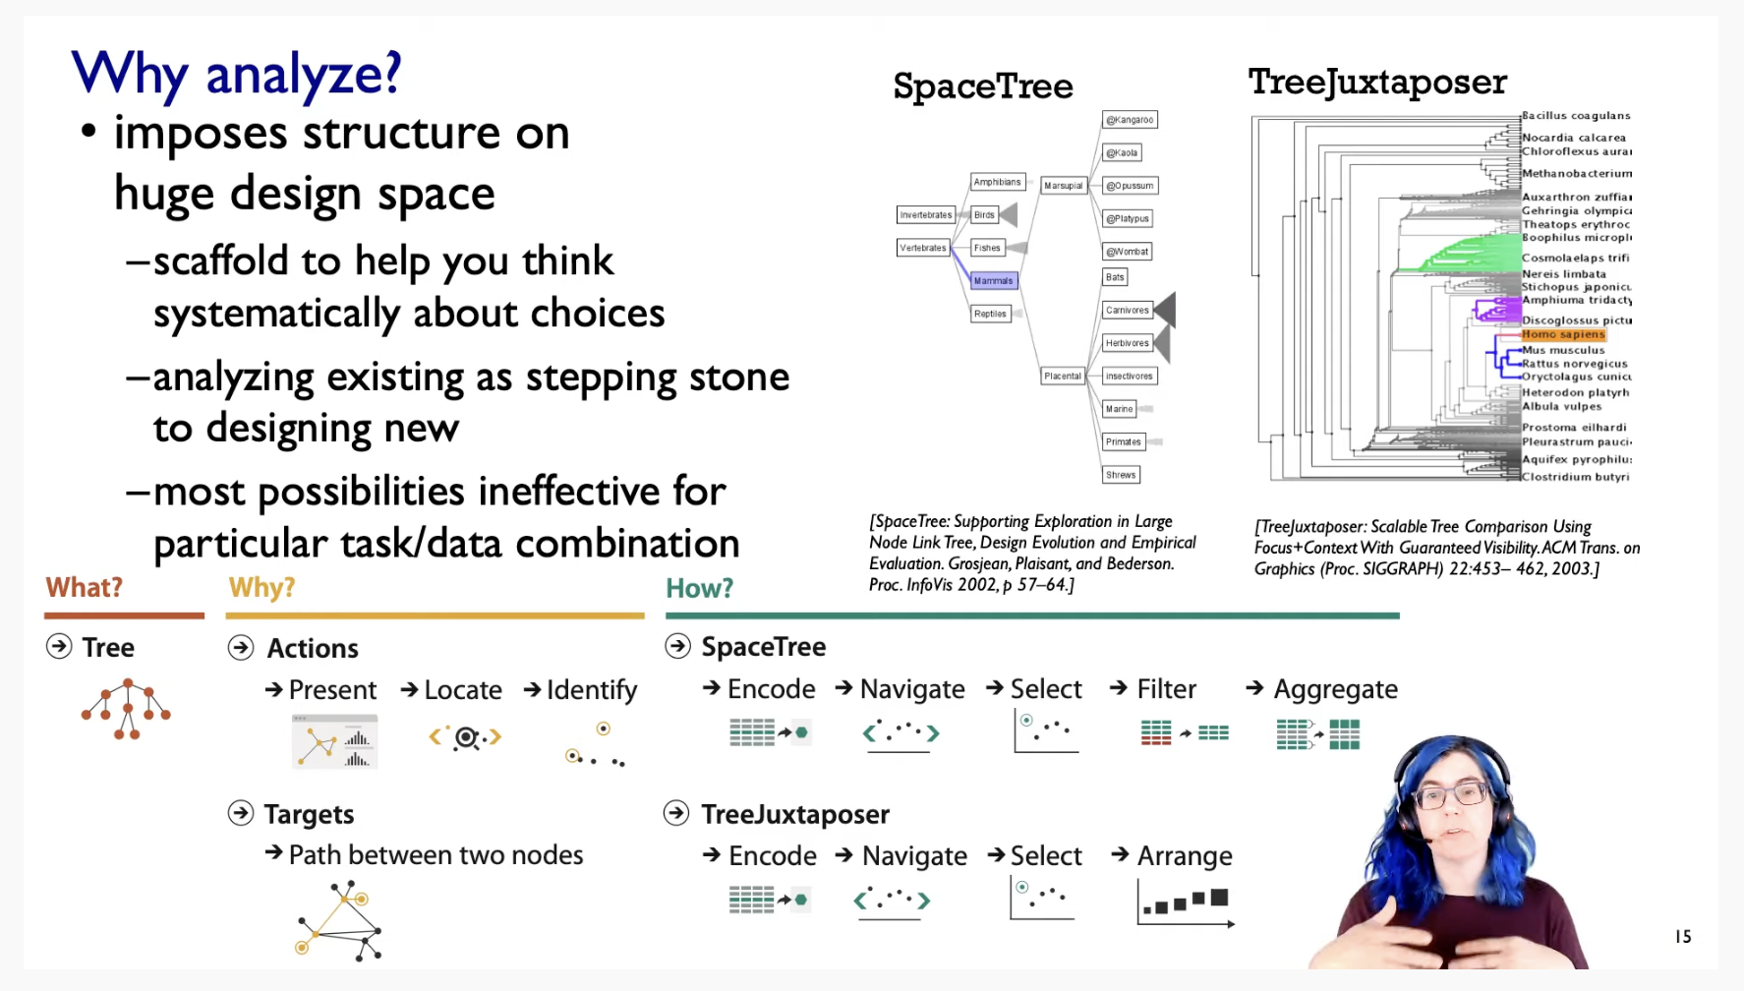

# **Data Abstraction**

These trees of ancestral relationships between species.  
Our aim is to find the leaf node from the root node.

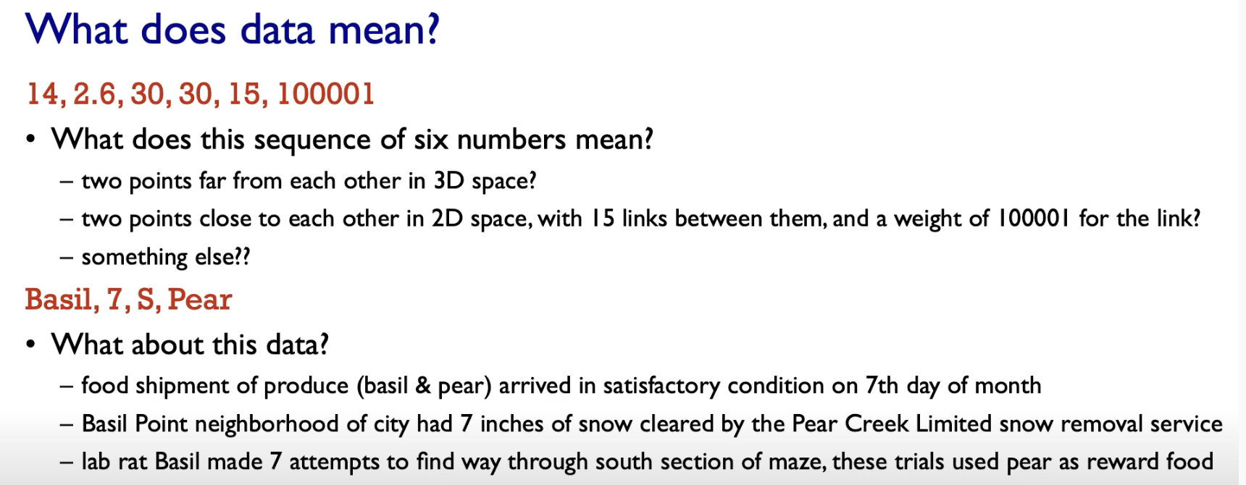

So when we have data, we need some sort of semantics that we attach to it.  
We need to use in the context of how visually show the data.

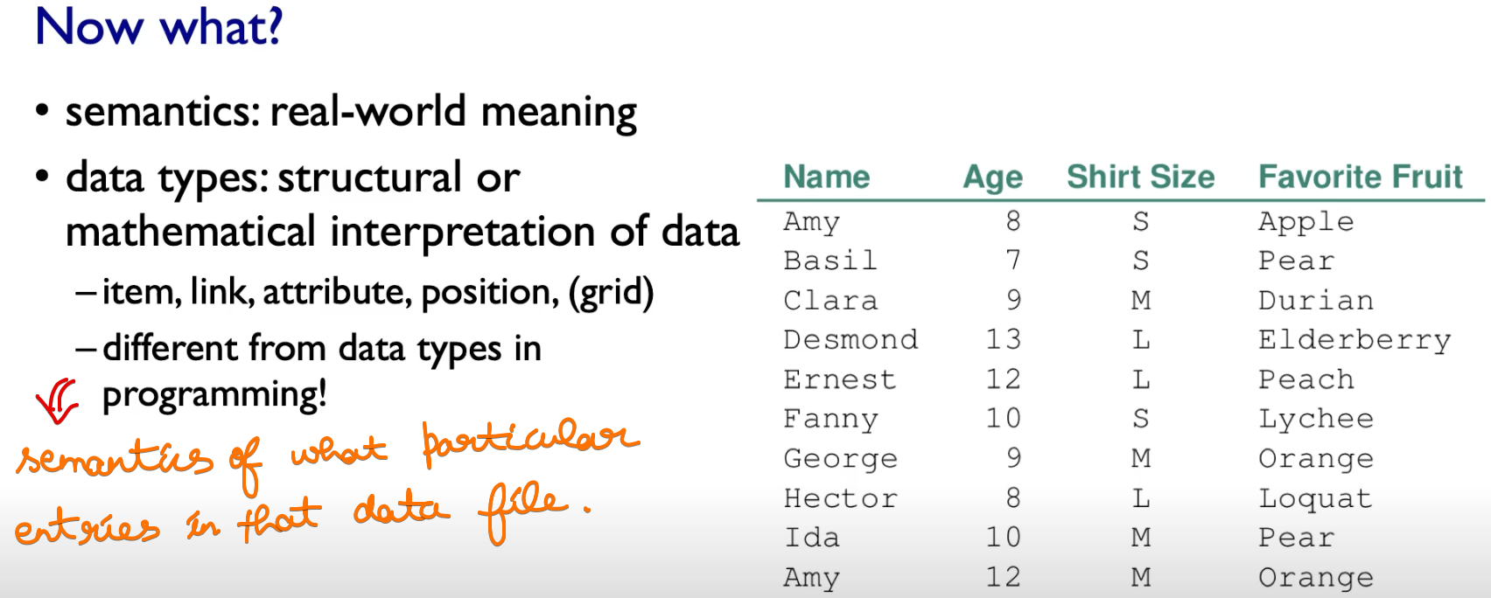

These data-types are not programming data-type, these are the semantics of what particular entries in that file.

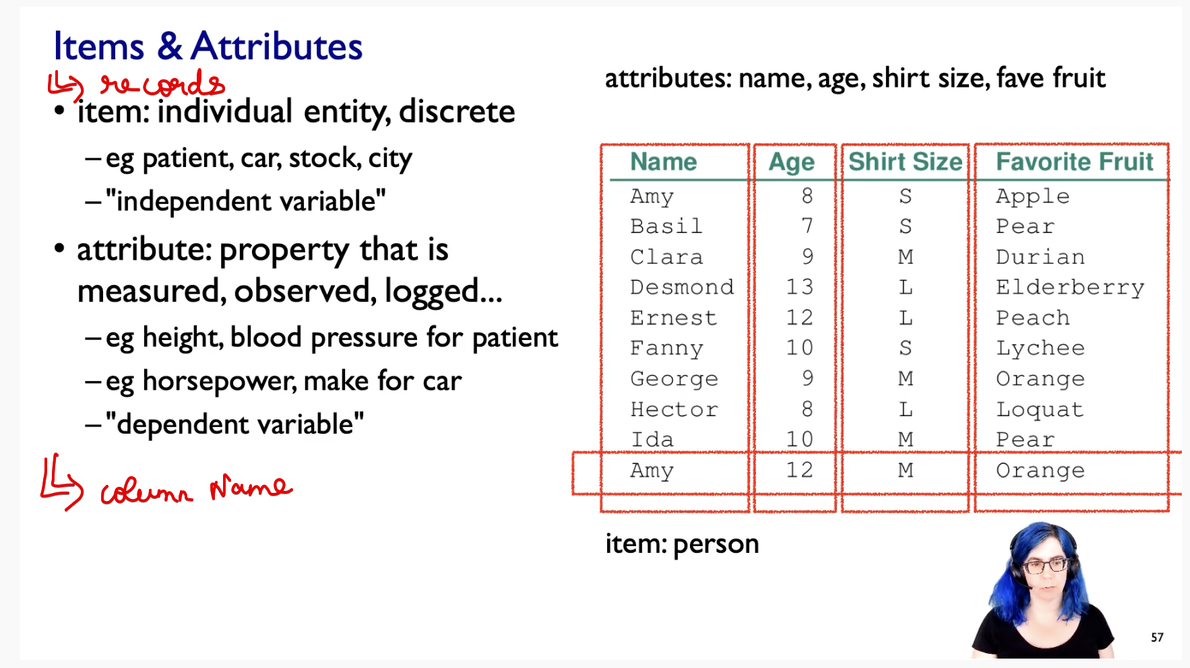

items 🡪 table rows   
attribute 🡪 column names

## **Data Types**

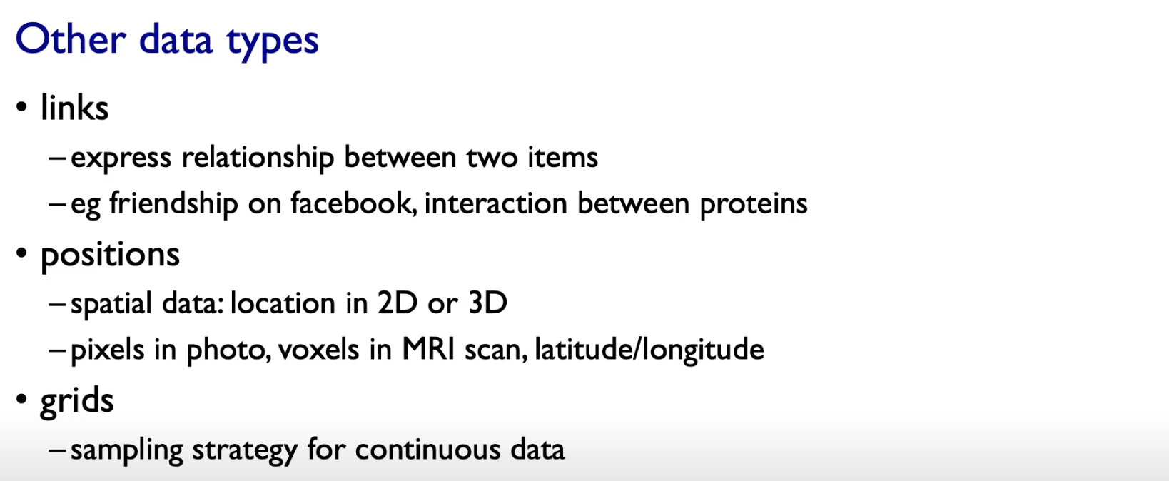

## **Data-set Types**

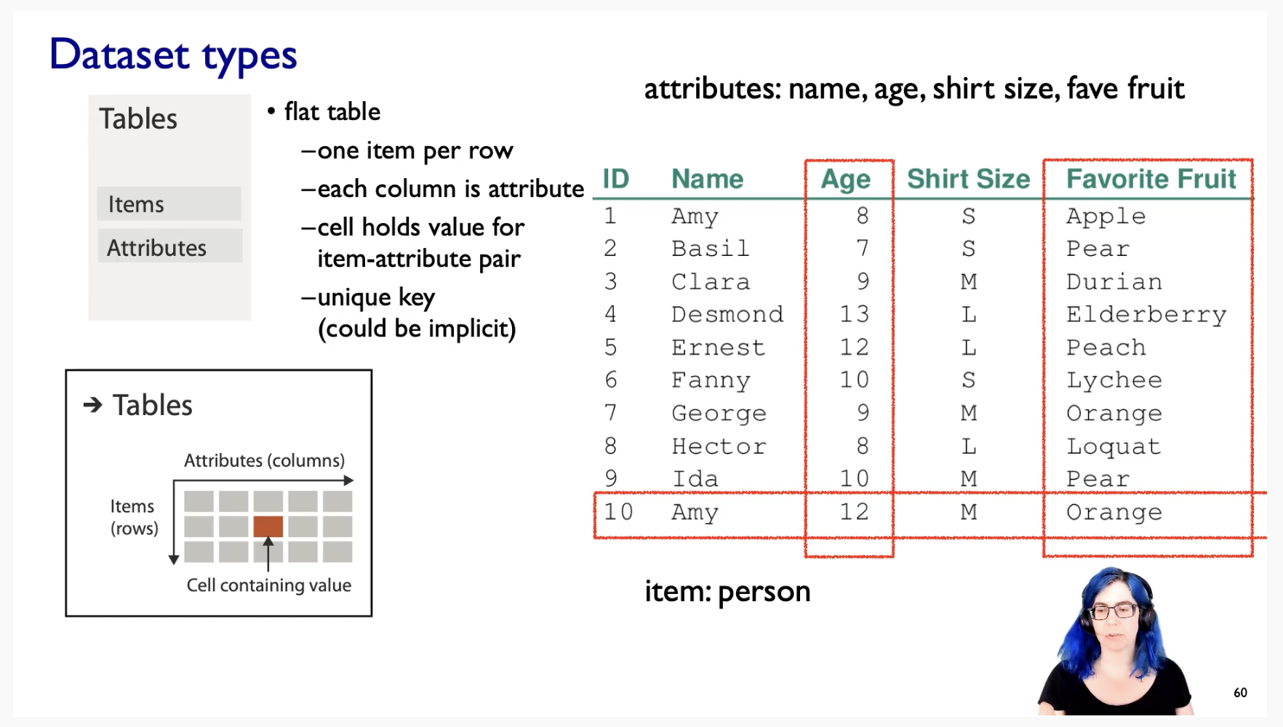

### **Tabular**

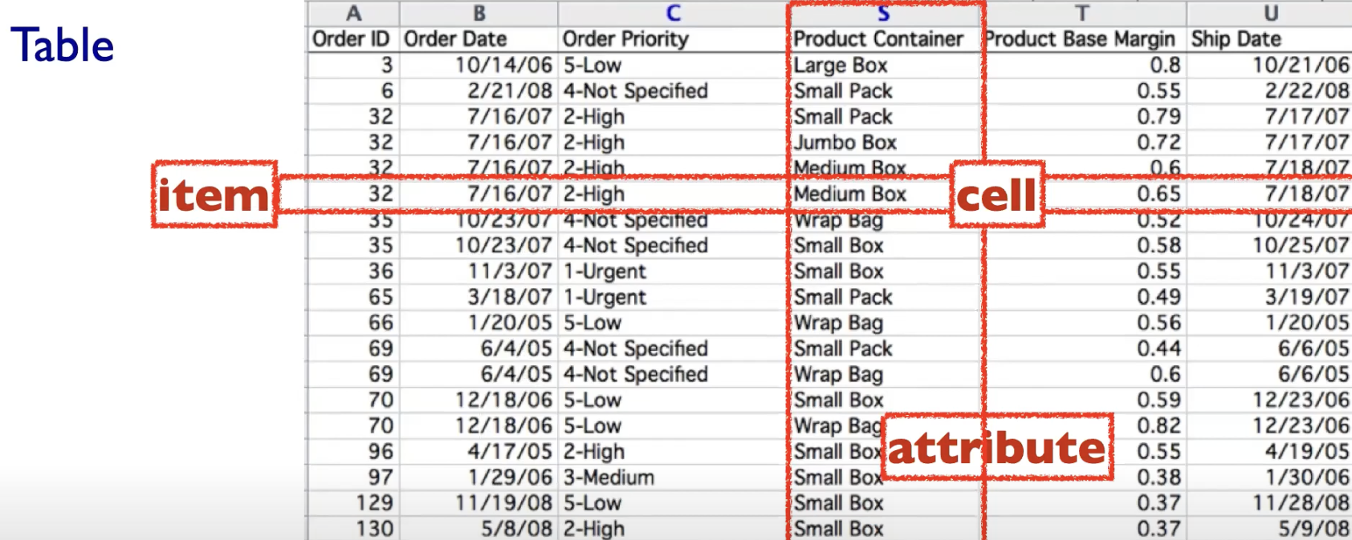

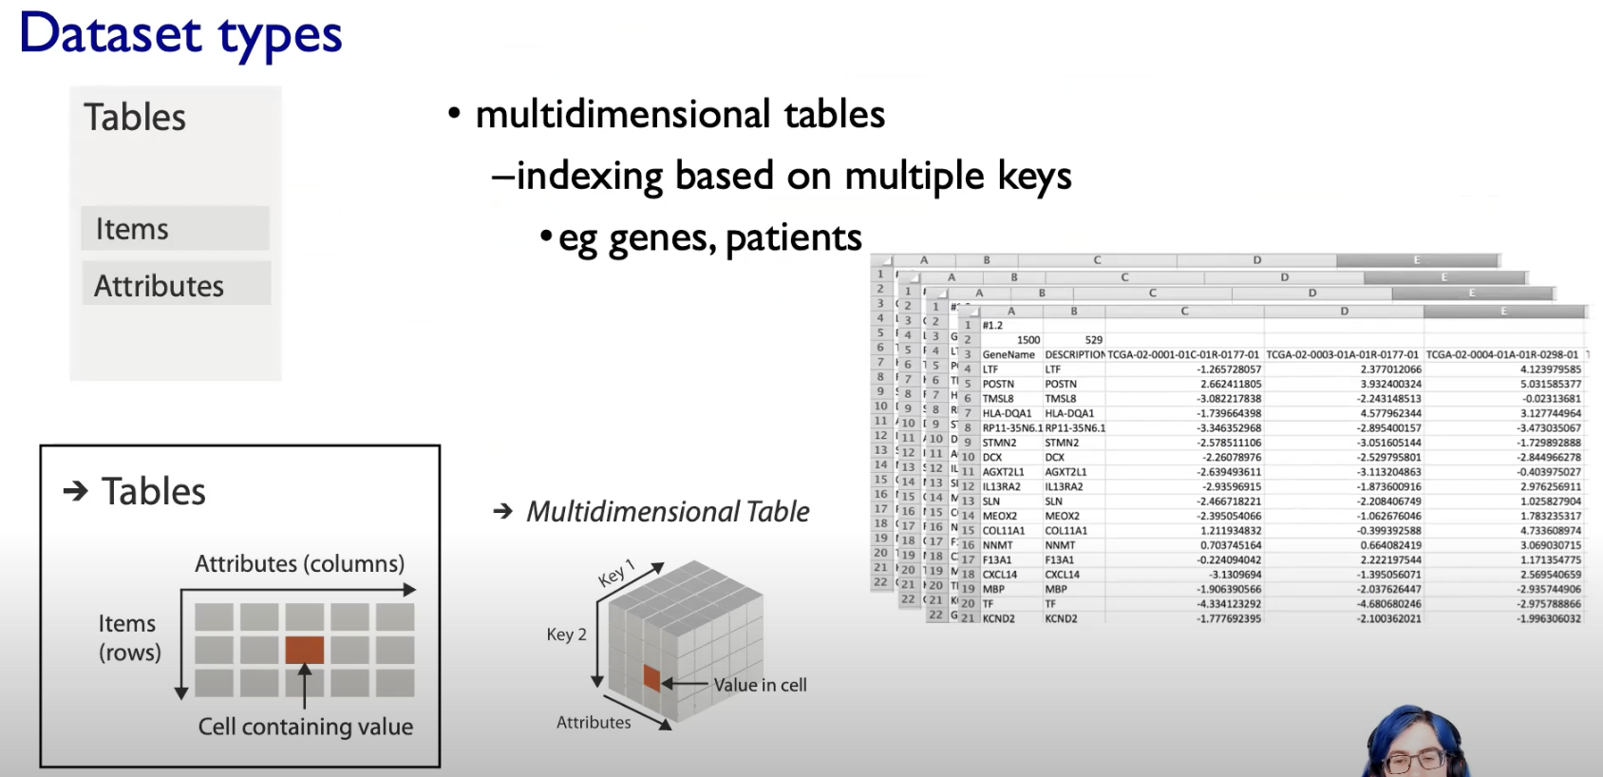

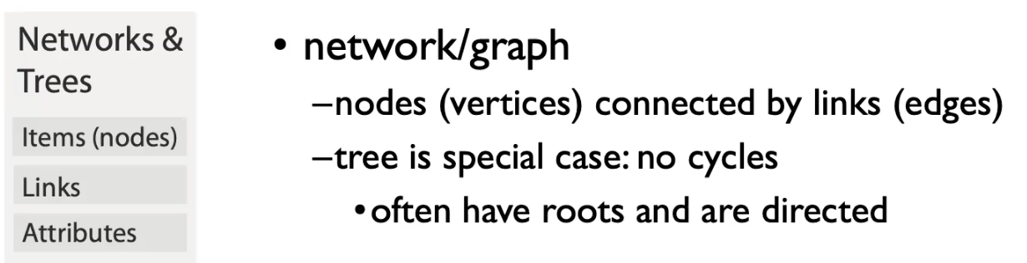

In Network context, the attributes could be either be attached   
to the nodes or the links or both.

So we can distinguish between Node-attribute and Link-attribute with the network data-sets.

### **Spatial Fields**

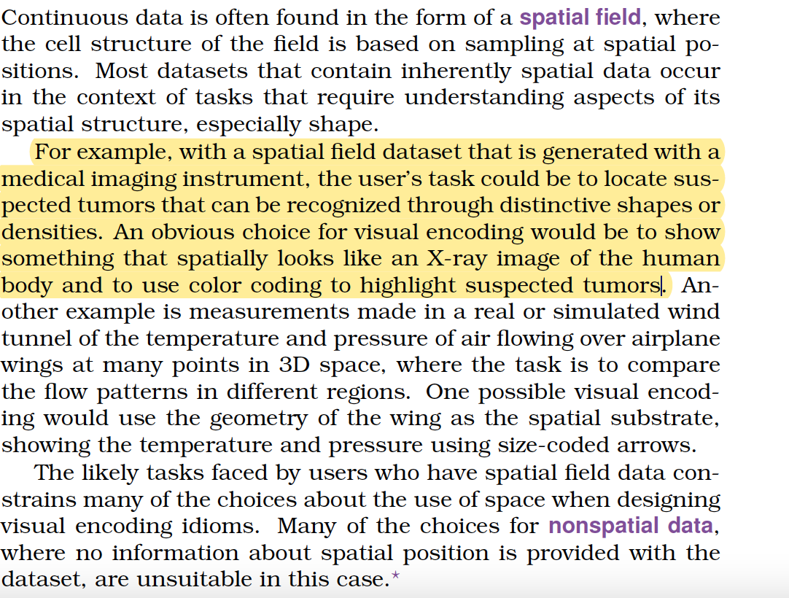

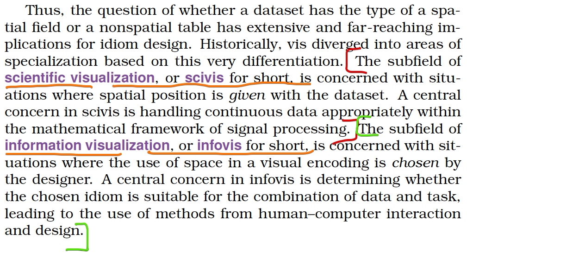

Here the attributes are tied upon a specific spatial locations or regions

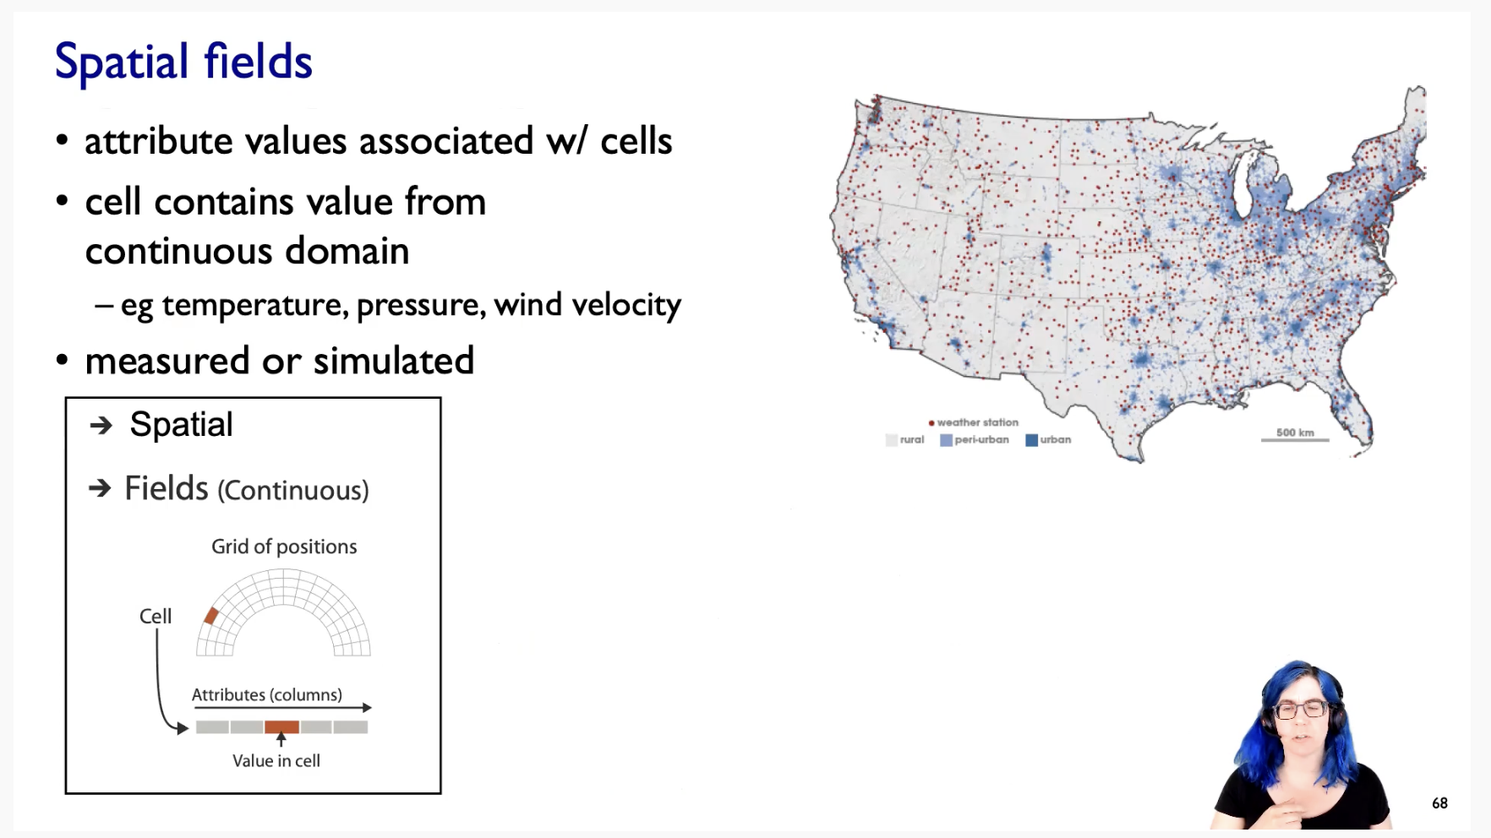

The idea is that we have cells that contains values from some sort of continuous spatial domain.  
Eg: In this geographic example, we could sample temperature, pressure, wind velocity at these different regions of space.

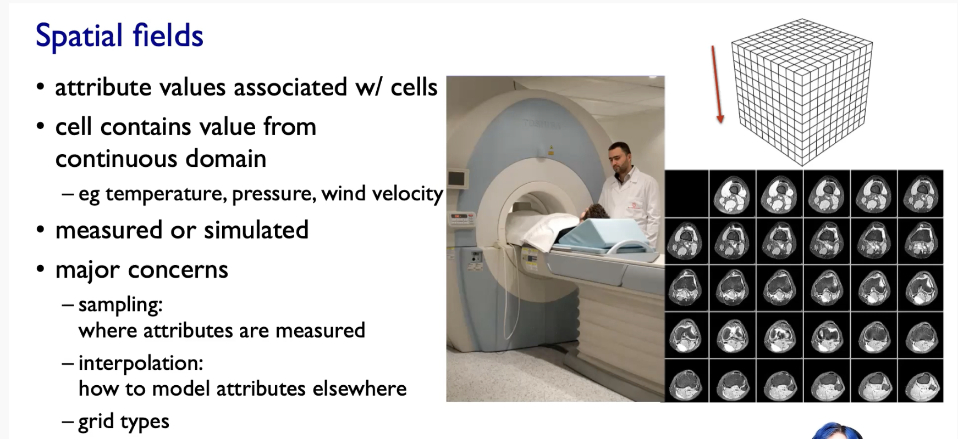

The major concern with the sort of continuous spatial field data collection is about sampling and interpolation.

Sampling 🡪 Where we are measuring these attributes ??  
Interpolation 🡪 How you would impute a value between sample points ??

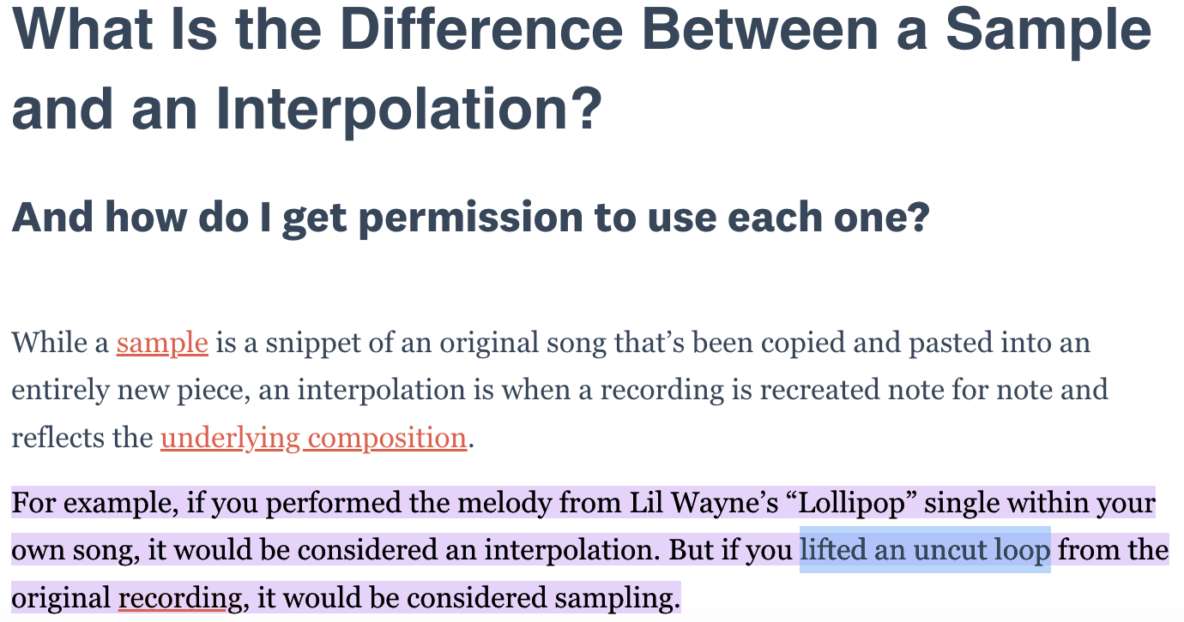  
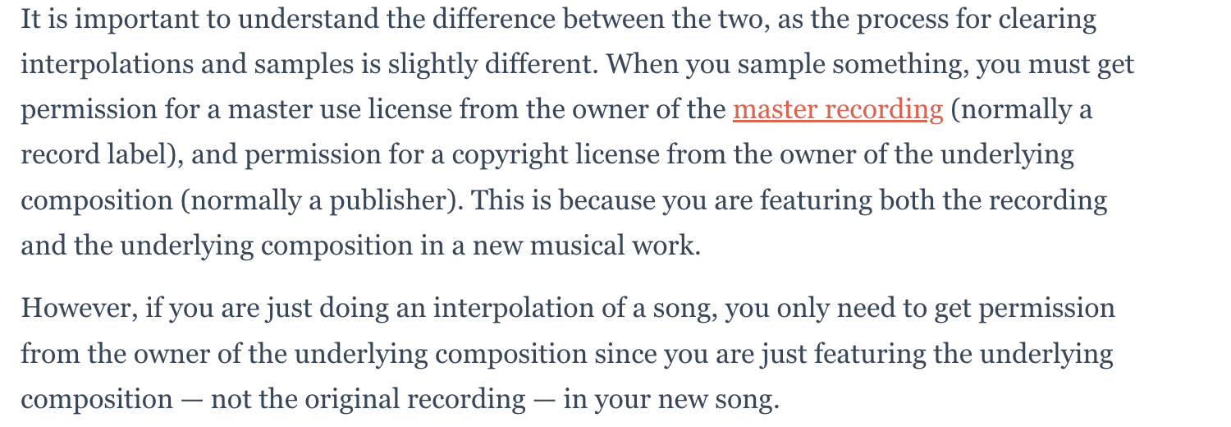

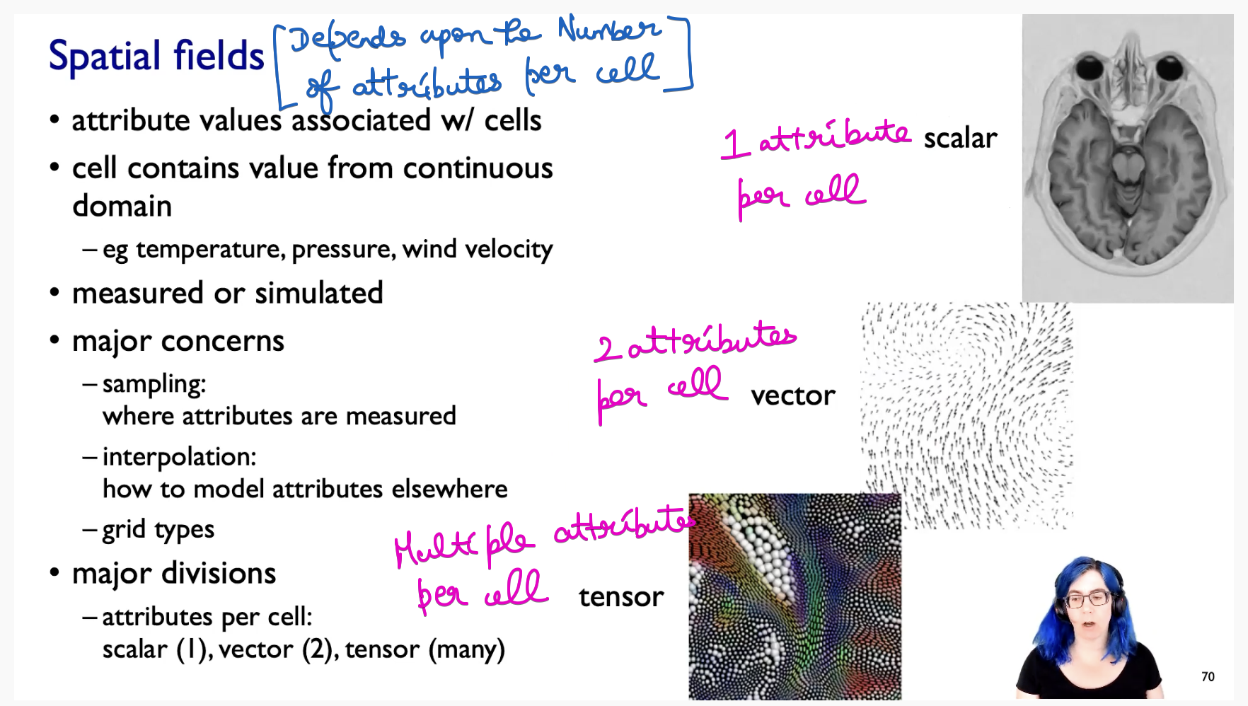

### **Geometry**

What is the boundary between computer graphics and visualization ??

In Computer graphics 🡪 The geometry you take as given. It is given to you, and then you have the problem of how to actually render the geometric information according to some sort of synthetic idea of where the cameras and light are .

In Visualization 🡪 We do worry about drawing that picture, which is equivalent to rendering graphics, but the key point is that the geometry is the result of a design decision by the visualization designer.

### **Collections**

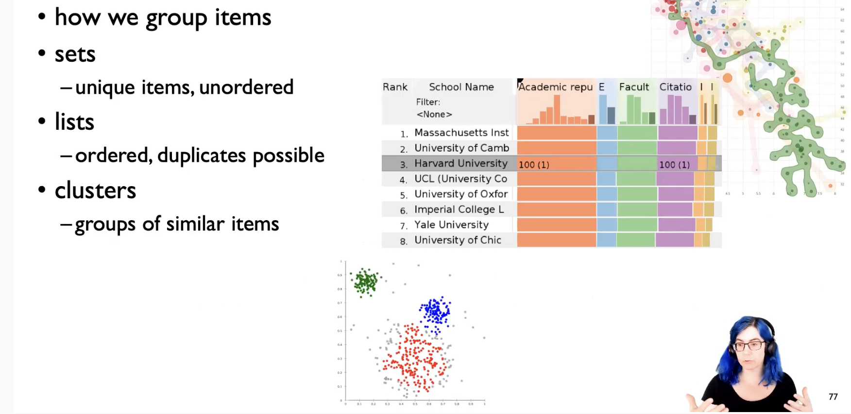

Collections are some sort of grouping the items

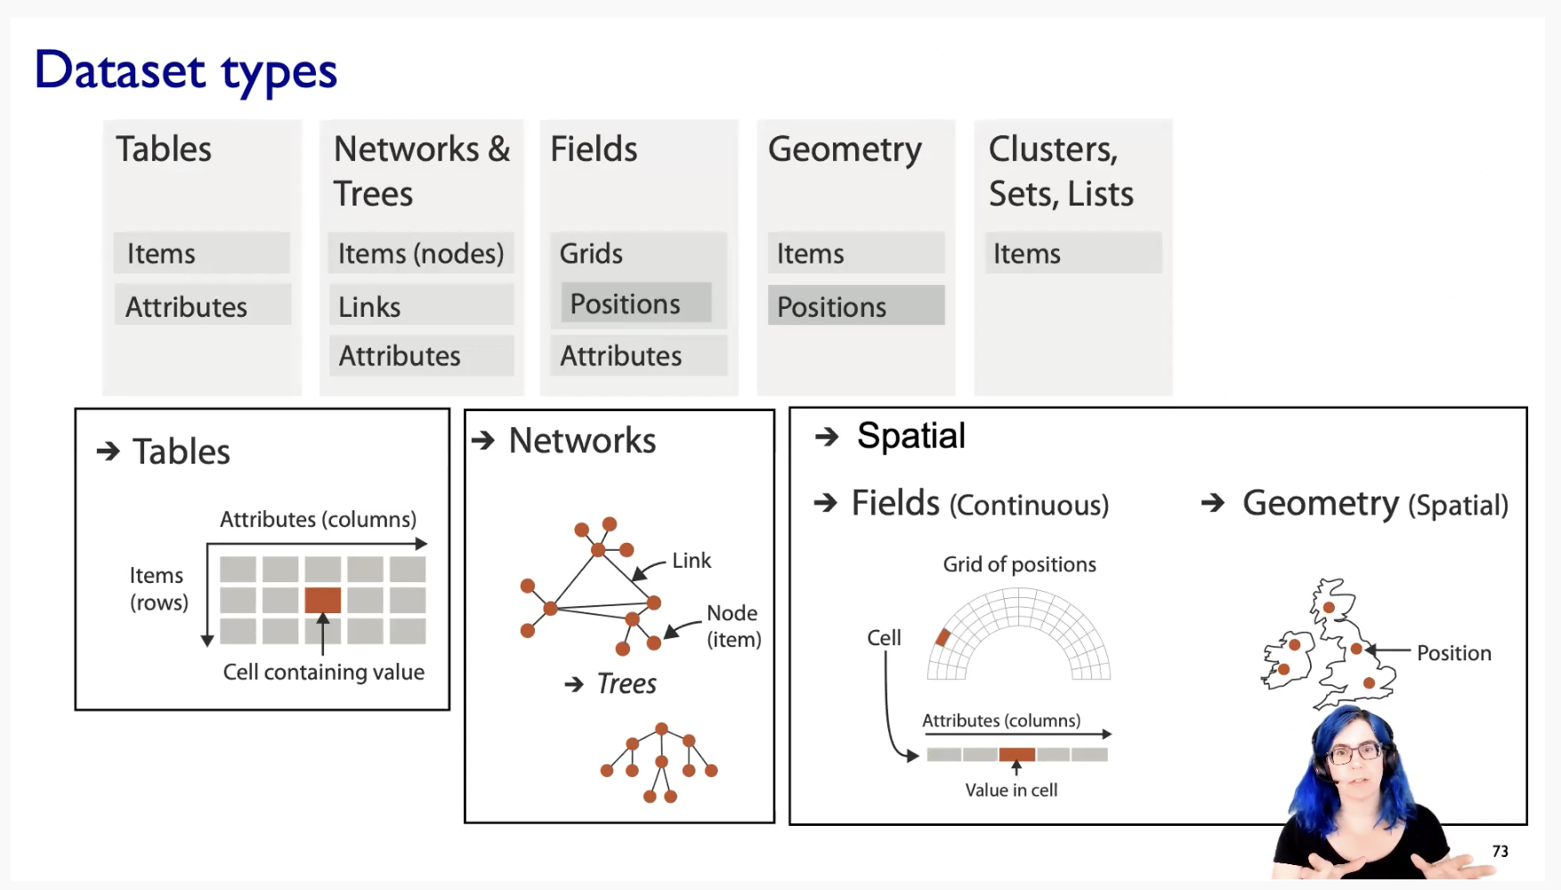

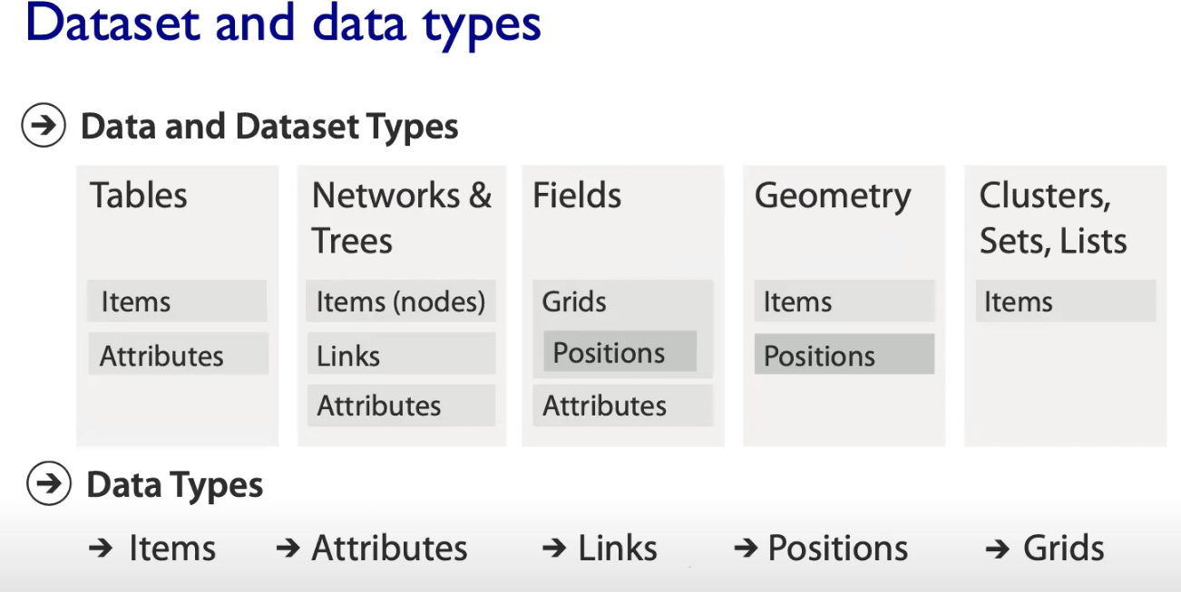

## **Attributes Types**

The main difference 🡪 Between categorical and nominal attribute.

**Nominal data** is classified without a natural order or rank, whereas **ordinal data** has a predetermined or natural order.   
On the other hand, **numerical or quantitative data** will always be a number that can be measured.

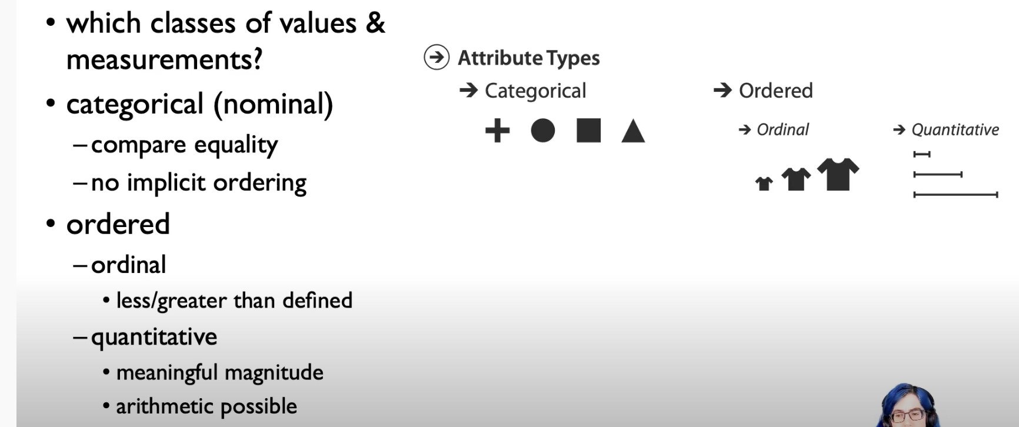

Ordinal Data 🡪 We can say medium t-shirt is between small and large t-shirts.   
But we cannot able to calculate Large t-shirt minus Small t-shirt.   
[No possible for doing any arithmetic’s]

Quantitative Data 🡪 We can do some arithmetic operations

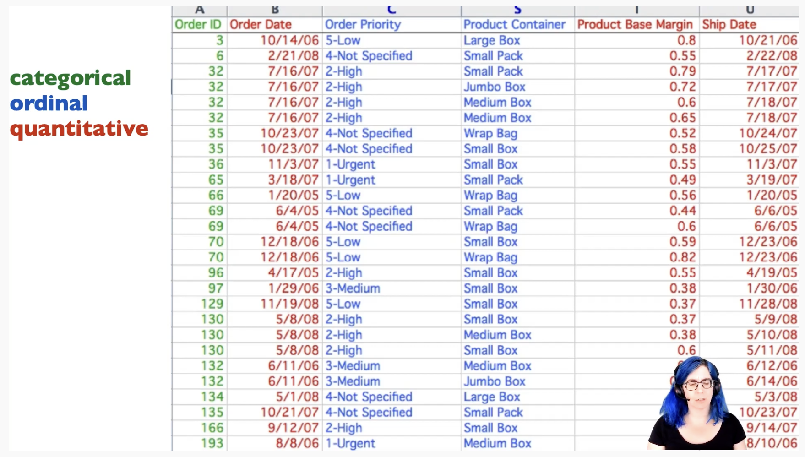

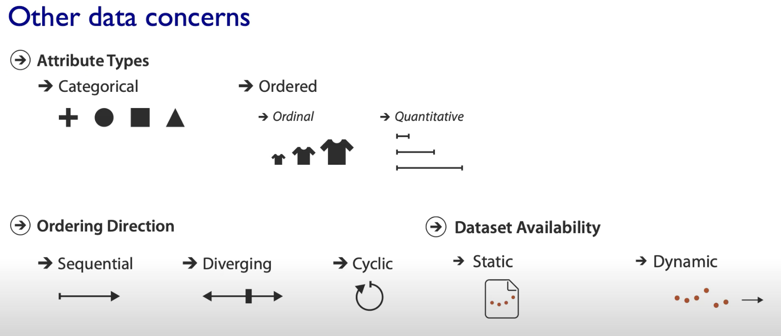

Sequential 🡪 From min to max (or) From max to min  
Diverging 🡪 left | threshold-point | right  
Cyclic 🡪 seasonal data (Repeats over a time)

Dynamic data 🡪 Streaming data (It’s is going to be streamed in as you are working with that data)

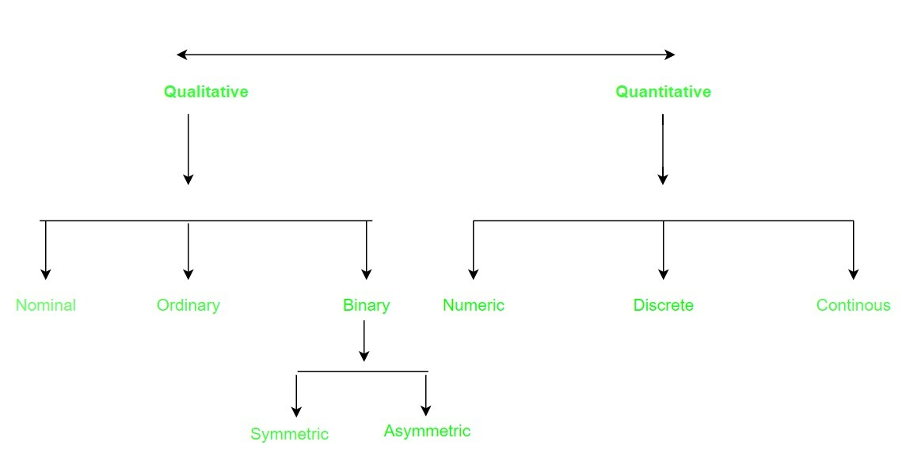

## **Major three operations**

What is Data Abstraction ?

We need to transfer the data from domain-specific language into some generic language of visualization.

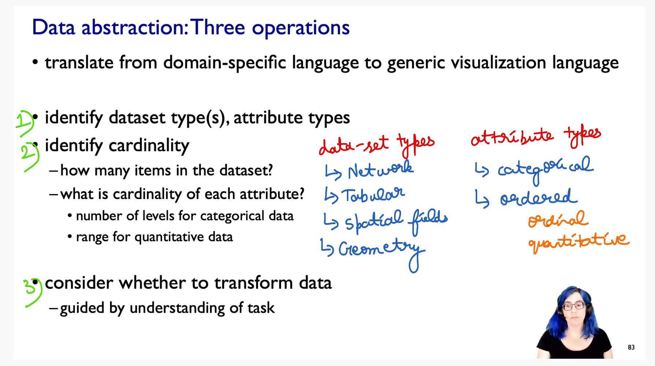

2) Cardinality:  
How many items are going to be in the data-set ??   
Whether it is 10, 10K , 1000K. The main reason we think about this is, it is going to affect your reasonable choices for how to visually encode that data.  
How many unique levels are there in each of the categorical attribute ??

3) 🡪Do I need to transform the data ???  
Can I take the data it as given ??   
(or) Do I need to transform it to some other kind of data ???

This consideration must be guided by under-standing the task.  
This is why the task and data are tied together in-terms of abstraction level.

## **What is meant by transforming the data ???**

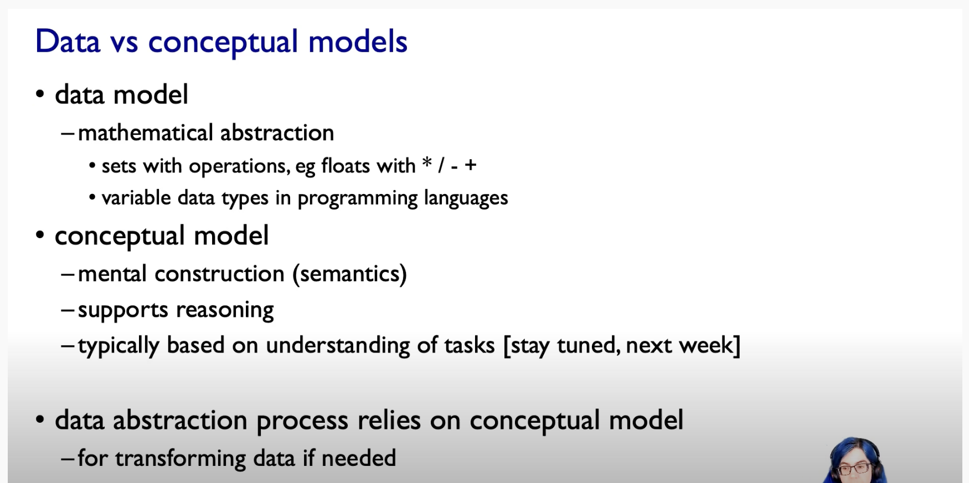

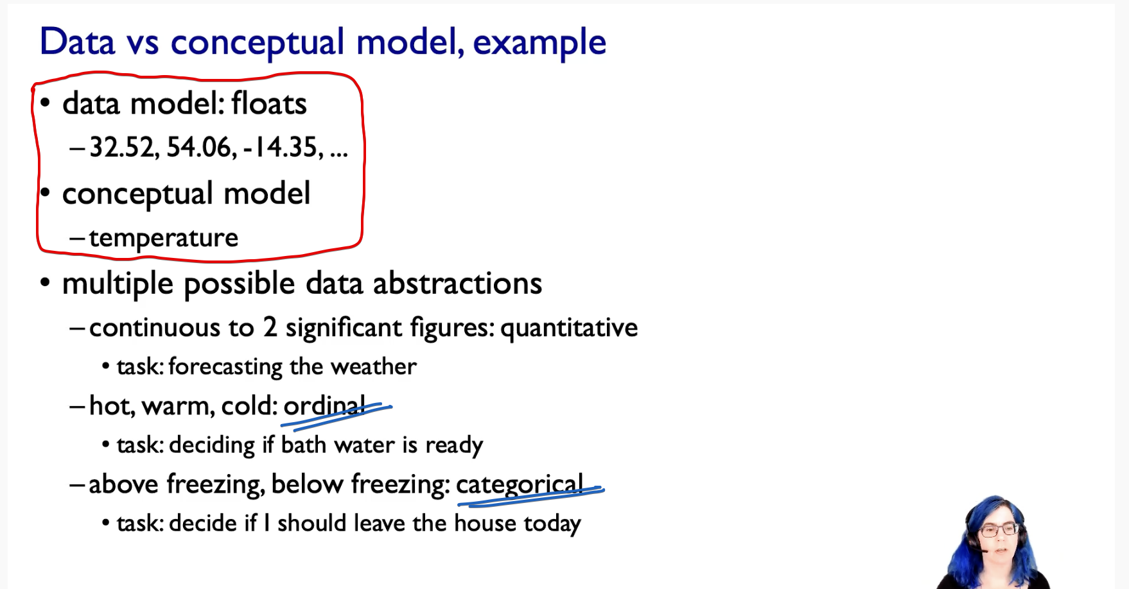

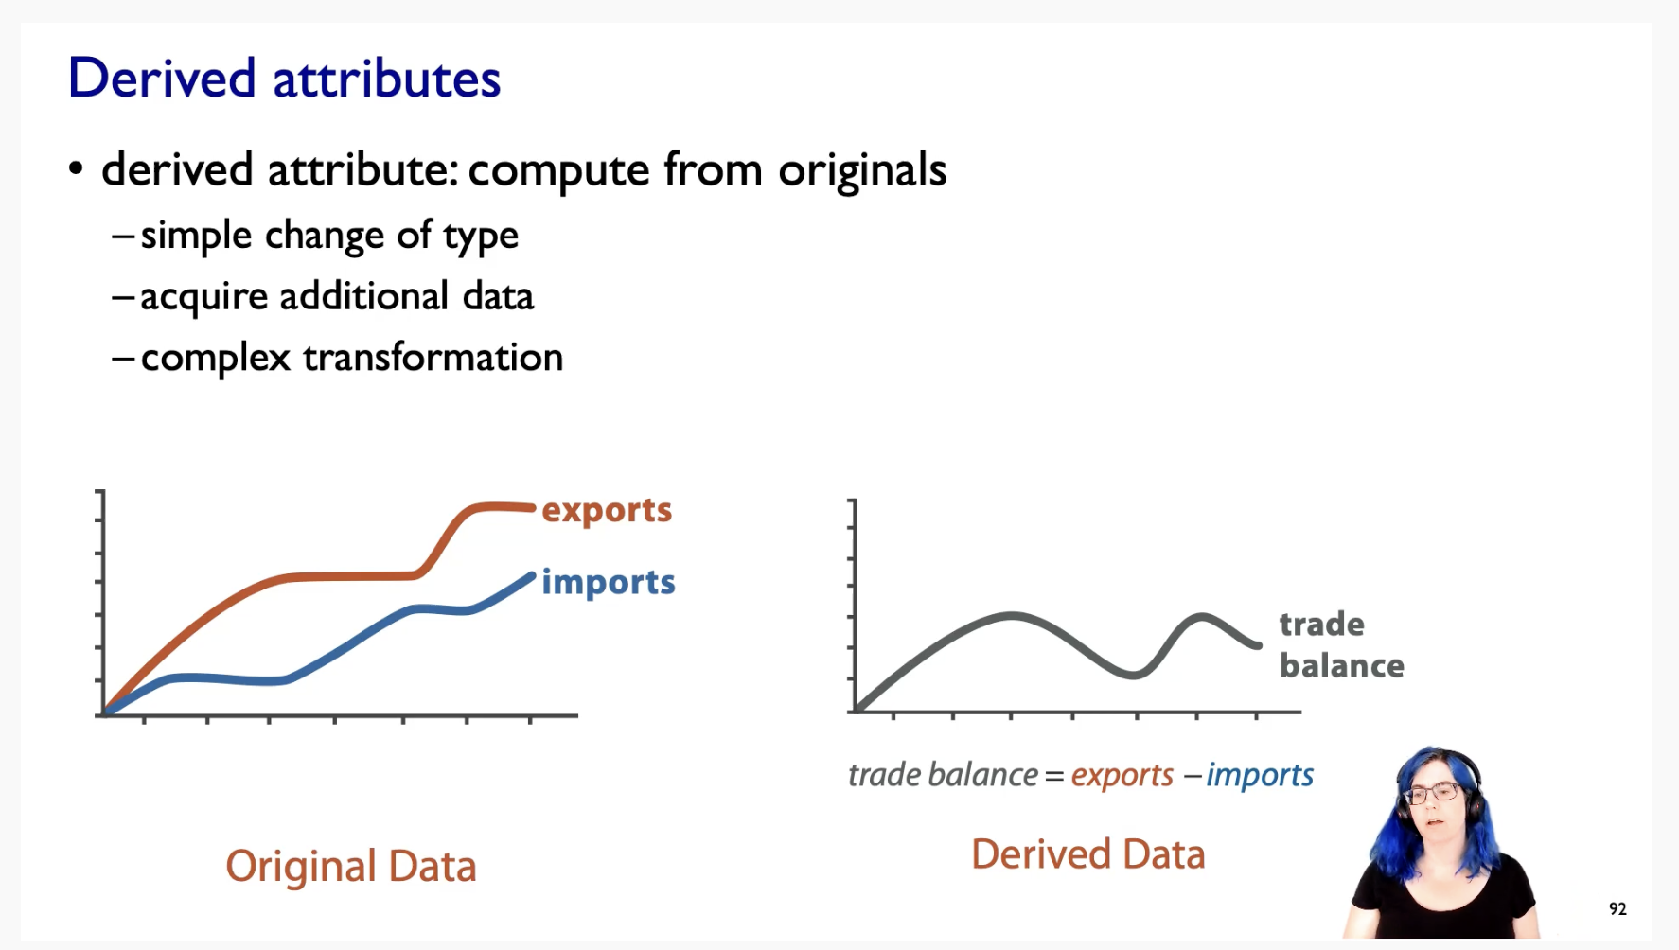

This is how data derivation can reduce the cognitive burden on the human looking at this.

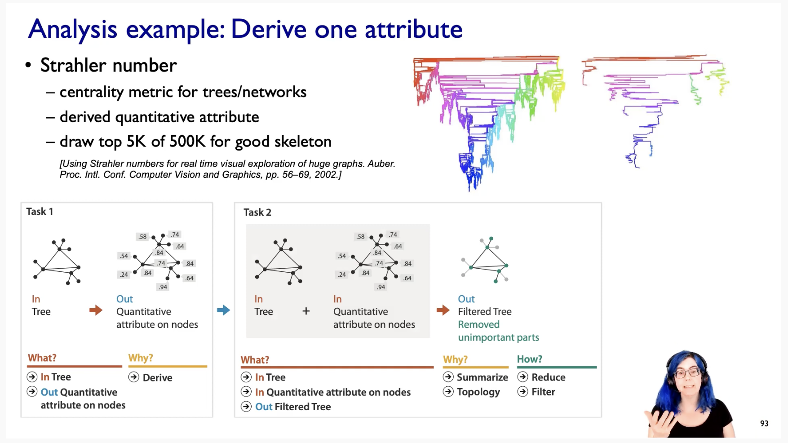

# **Task Abstraction**

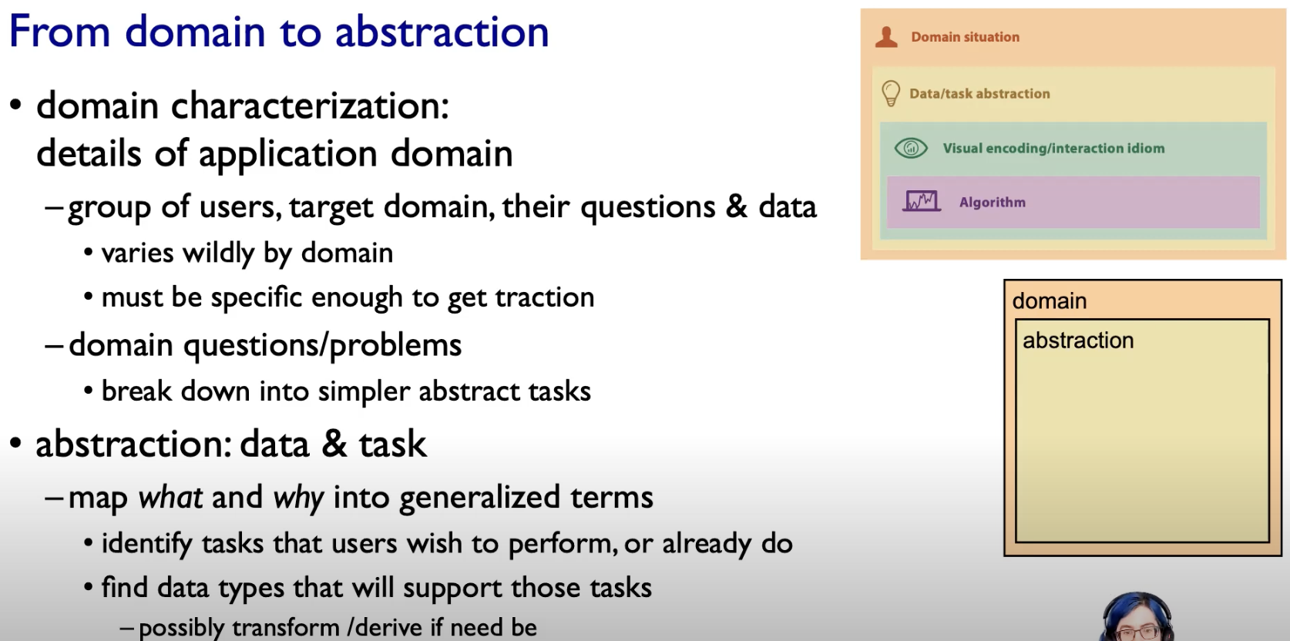

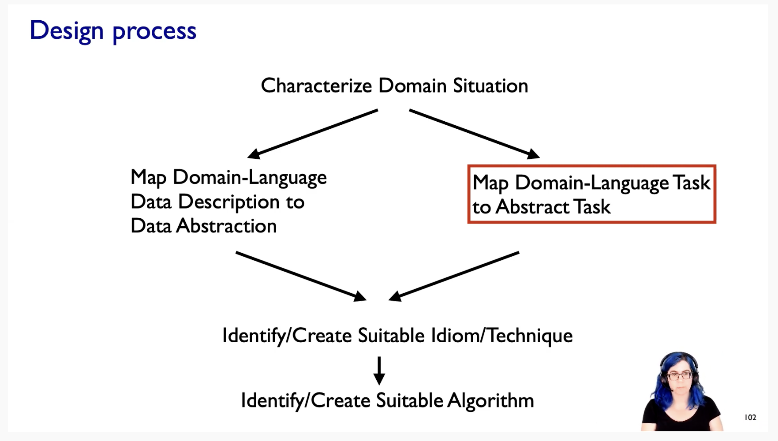

## **Actions : Analyze**

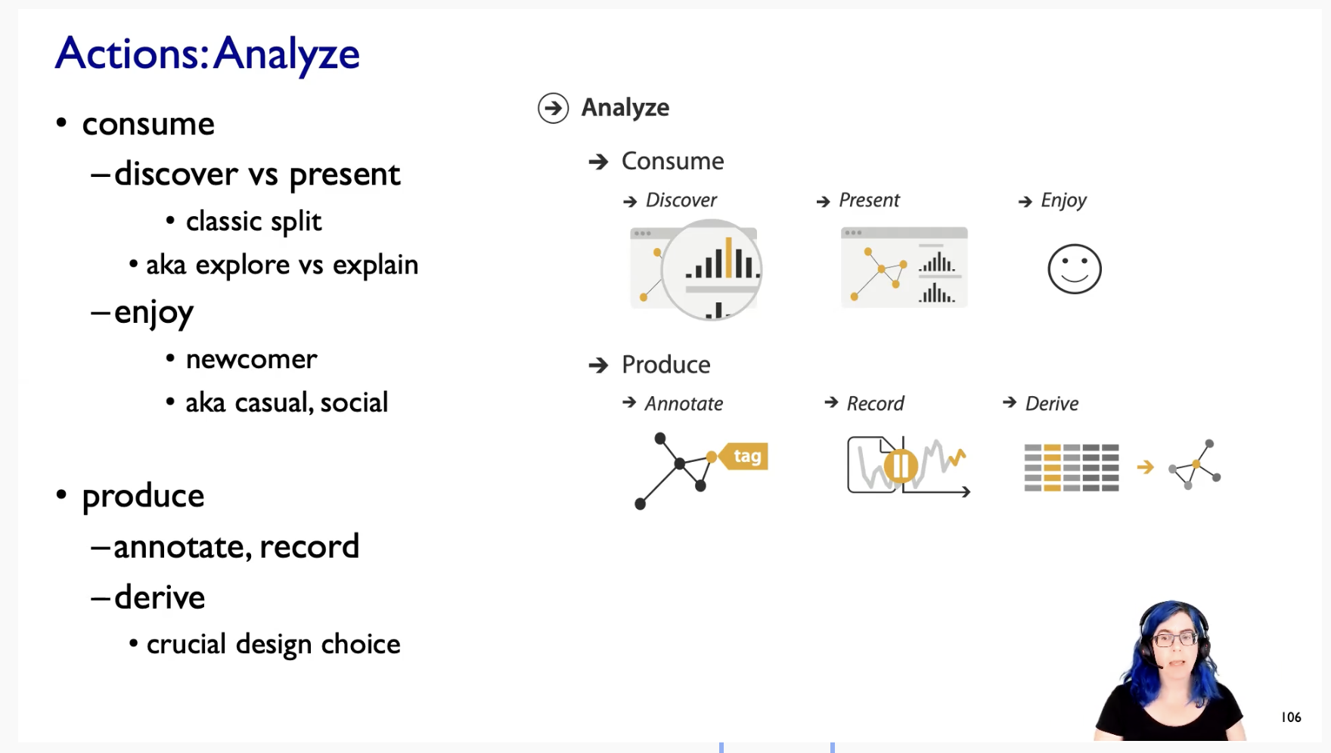

## **Actions : Search**

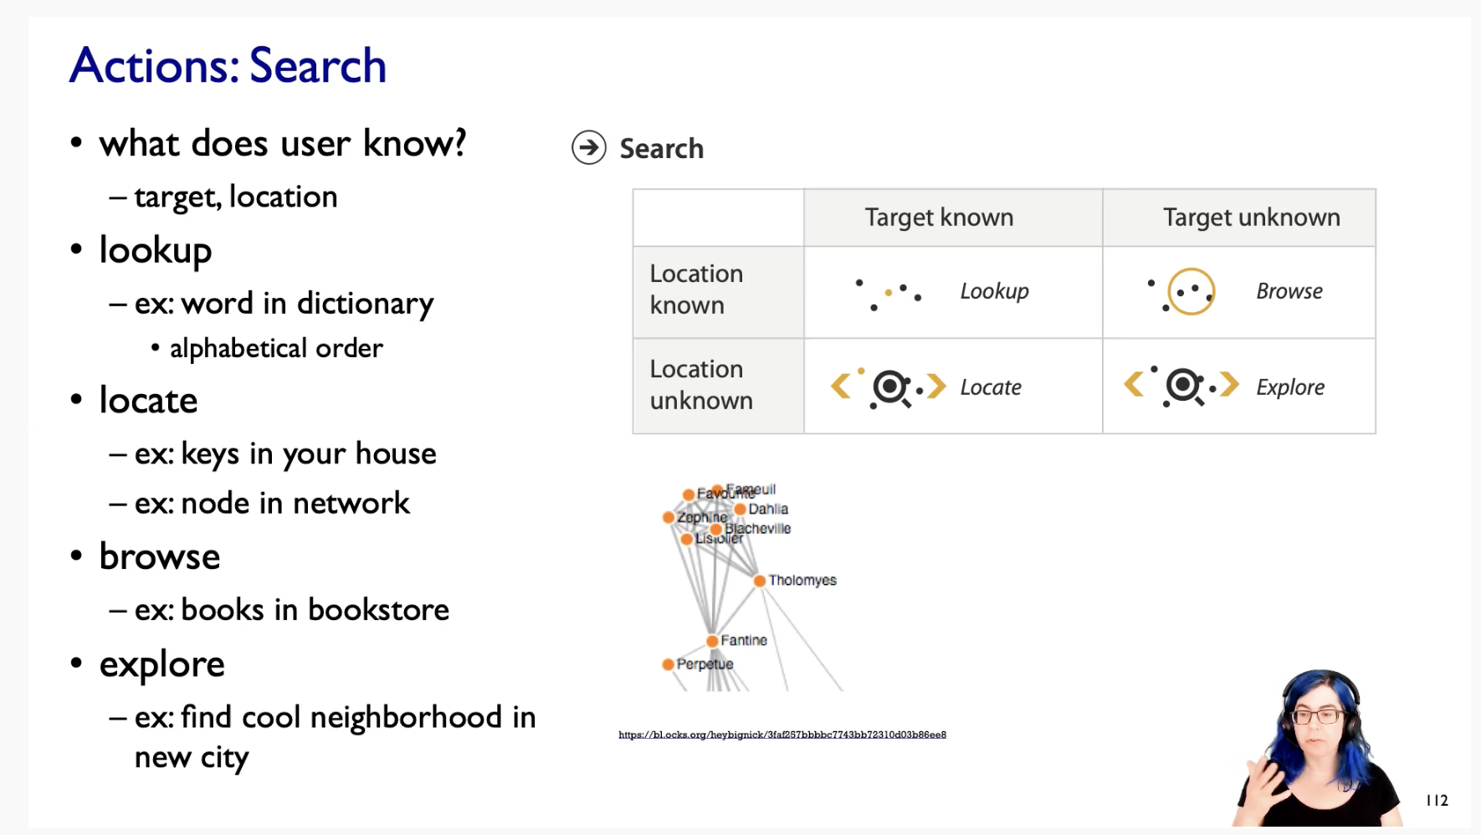

## **Actions : Query**

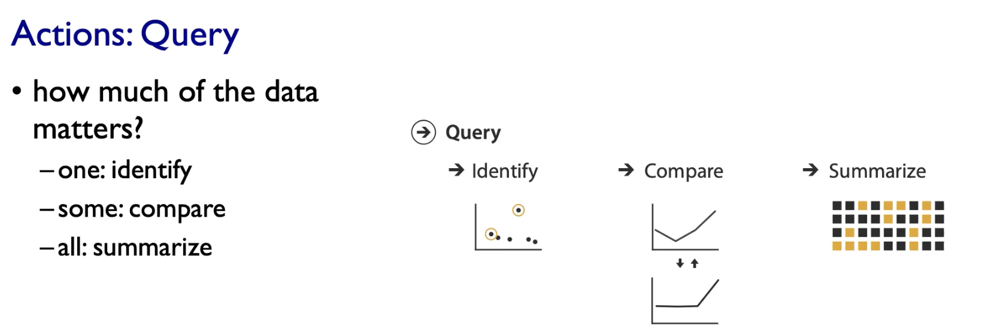

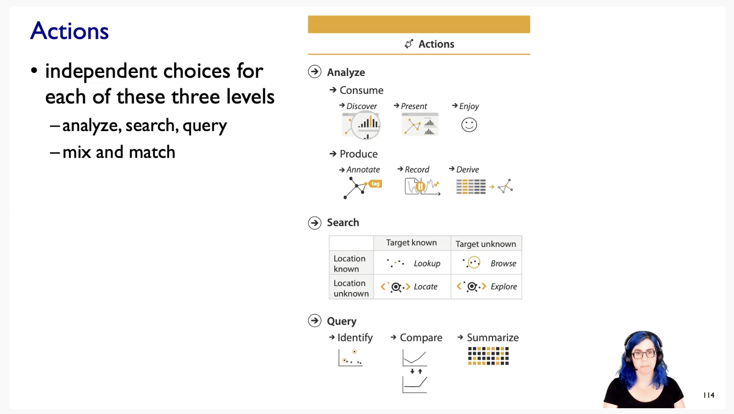

Analyse, Search and Query are completely in-dependent of each-other.

## **Target**

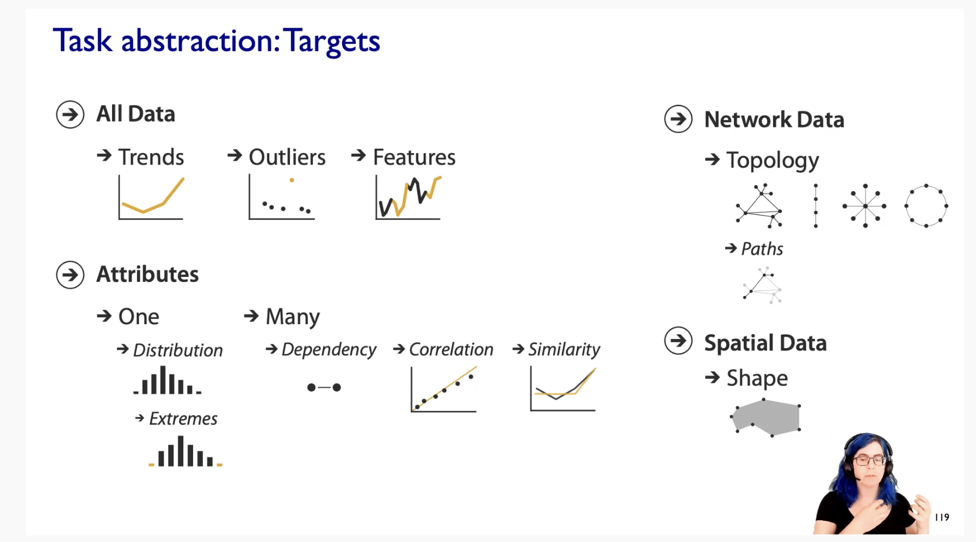

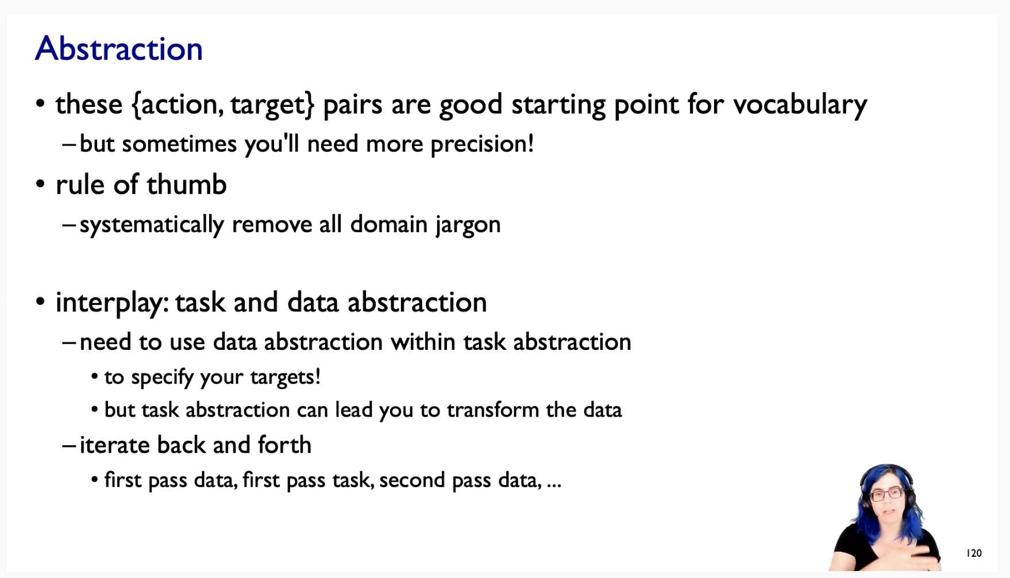

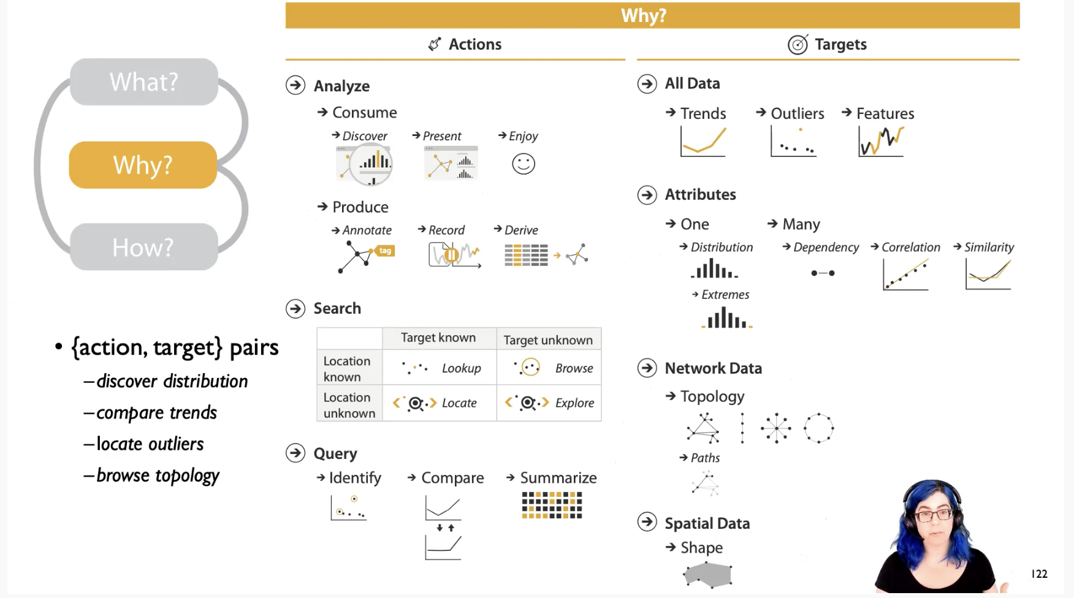

# Exercise

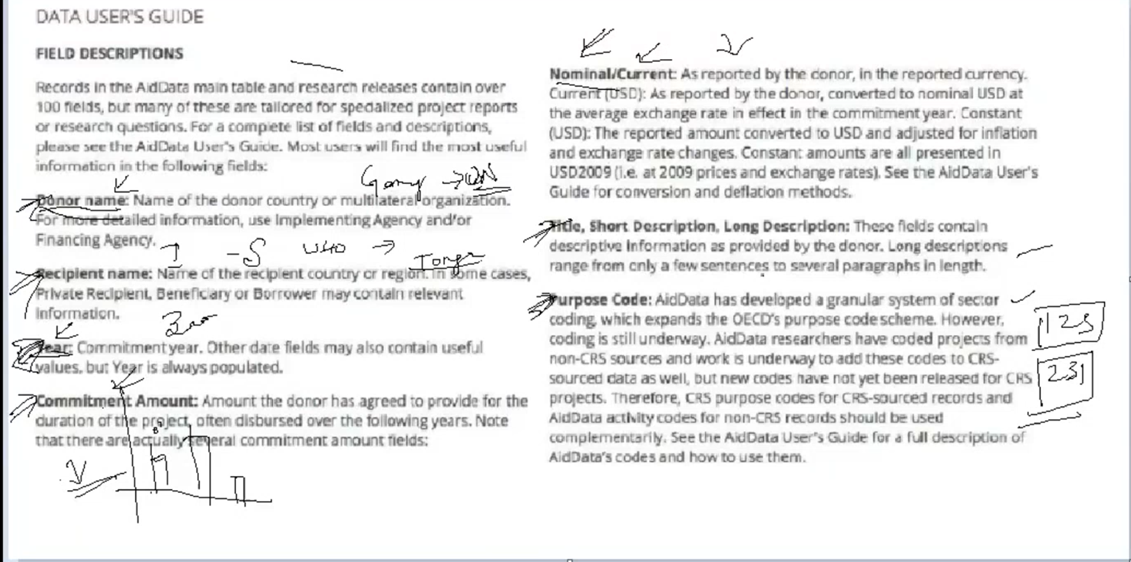

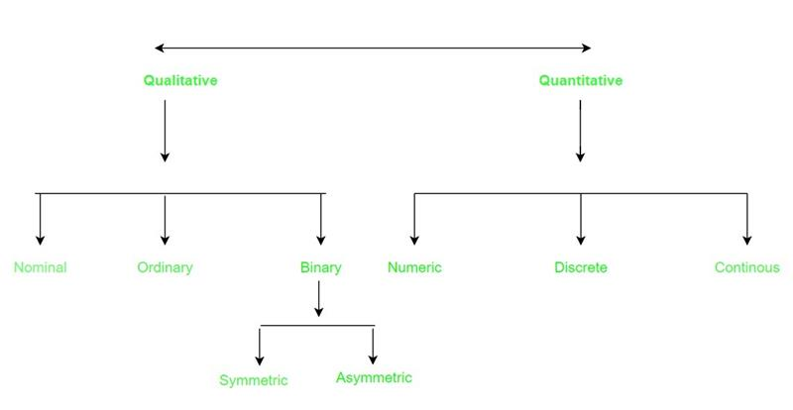

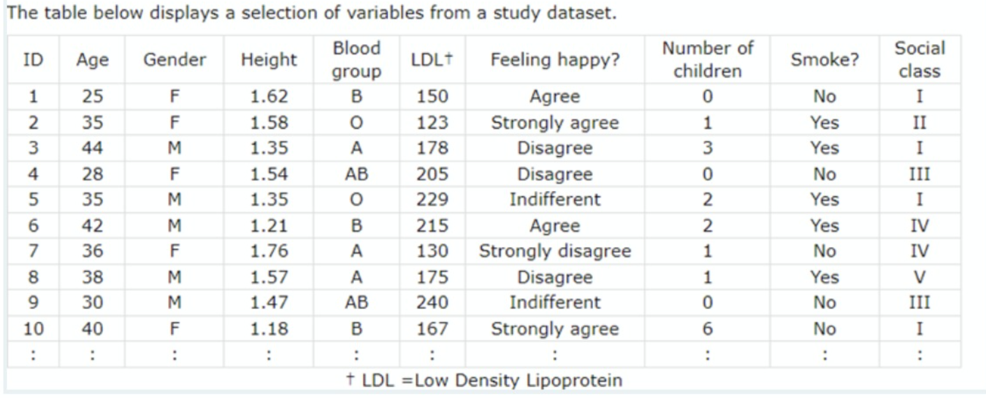

Quantitative variables 🡪 Age, Height, LDL+, Number of children  
Qualitative variables 🡪 Gender, Blood Group, Felling happy?, Smoke?, Social class  
Continuous variable 🡪 Age, Height, LDL+  
Discrete variables 🡪 Number of children ?

Ordinal attributes 🡪 Social class, Felling happy?  
Nominal attributes 🡪Gender, Blood Group, Smoke?  
Binary attributes 🡪 Gender, Smoke?